**Machine Learning End-to-End Project Documentation**

**Steps to follow:**

1. **Collect & load the data to Build Machine Learning Model**
   1. Data Loading

* Load the dataset required for the machine learning model. Ensure the data is pre-processed as needed.
  1. Model Building
     + Build the machine learning model using your preferred framework or library (e.g., scikit-learn, TensorFlow).
     + Train the model and save it as a pickle file.

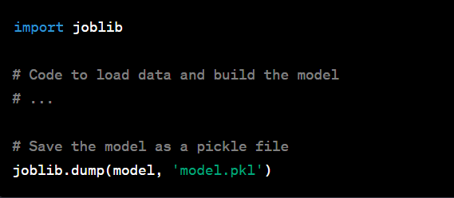

1. **GitHub Account**

Ensure you have accounts on [GitHub](https://www.github.com) (for version control).

1. **Create Git Repo and Clone into Local**

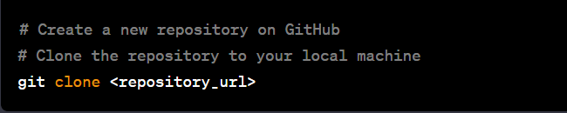

1. **Copy Files**

* Copy all the files from step 1 (data, model, and Jupyter notebook) to the local repository.

1. **Write Readme and Requirement Text File**

* Create a README.md file detailing the project, its purpose, and how to use it.
* Create a requirements.txt file listing all the dependencies.

1. **Create a New Work Environment**

* Create a virtual environment for the project to avoid conflicts with system-level dependencies.

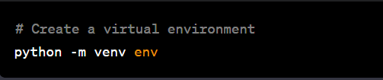

1. **Install Requirements**

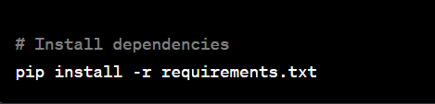

1. **Setup GitHub Credentials Globally**

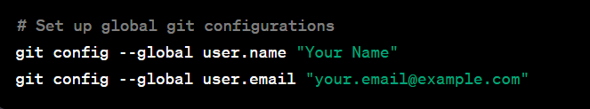

1. **Git Add, Status, Commit, Push**

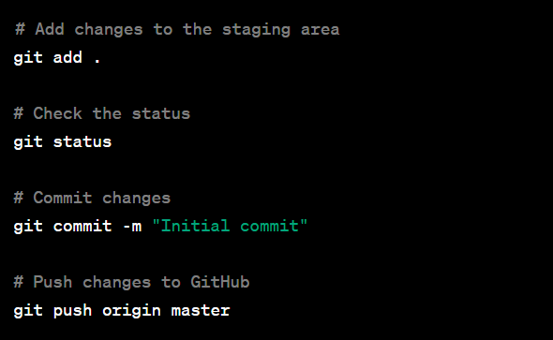

1. **Create app.py Along with index.html File**

* Create an app.py file for deploying the machine learning model as a web application.
* Create an index.html file for the user interface.

1. **Repeat Step 9**

